**DEVELOPMENT OF CvSU – SC COMPUTER LABORATORY TROUBLE TICKETING SYSTEM**

Undergraduate Thesis

Submitted to the faculty of the

Department of Information and Technology

Cavite State University-Silang Campus

Silang Cavite

In partial fulfillment

of the requirements for the degree

Bachelor of Science in Information and Technology

**JOHN ERICK M. BAUYON**

**JOHN MICHAEL N. LAMADRID**

JUNE 2019

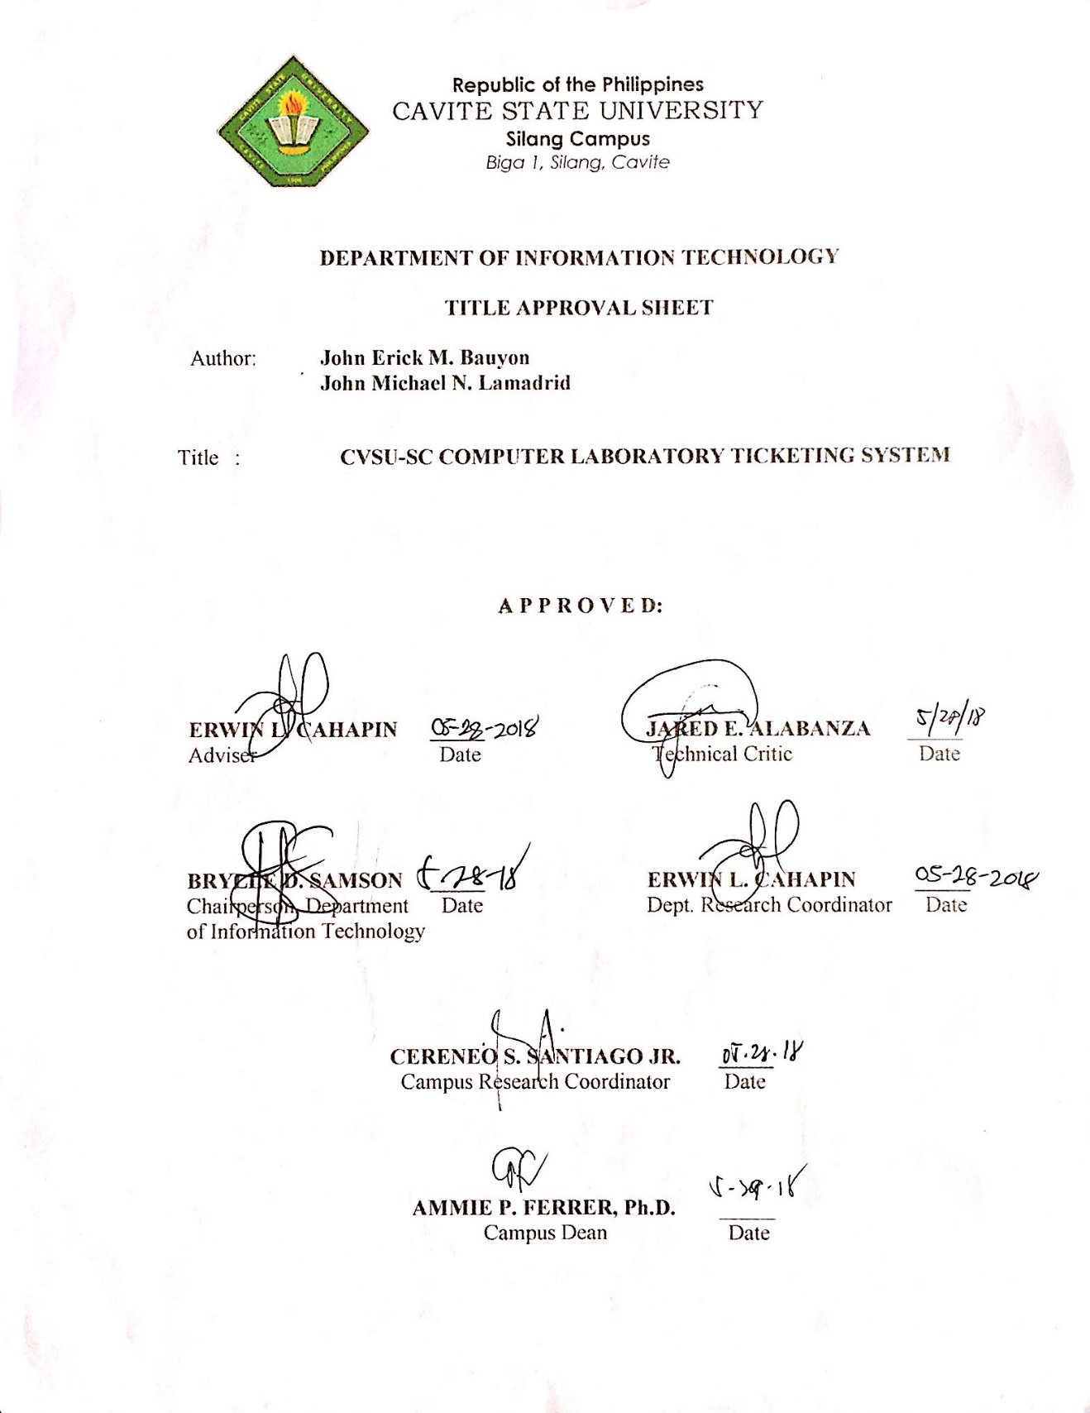

**BIOGRAPHICAL DATA**

**John Erick M. Bauyon,** 21 years old born on November 18,1997 in Silang, Cavite and currently living in Brgy. Narra 3 Silang, Cavite. He is loving, caring and only child of Mr. Ely Bauyon and Mrs. Jessica Bauyon. His father is working as a liaison associate.

He finished his primary education at Bagong Buhay Elementary School at Silang, Cavite in 2009. He finished his secondary education at Bulihan National High School at Silang, Cavite in year 2013. After graduating high school, he enrolled a two-year course at Philippine Technological Institute of Science Arts and Trade in 2013 taking Information Technology.

In June 2015, he decided to continue his studies at Cavite State University – Silang Campus to pursue his degree in Information Technology. He took his 200 hour of On-The-Job training on June 2018 to August 2018 at Unicapital Inc.

**BIOGRAPHICAL DATA**

**John Michael N. Lamadrid,** 19 years old born on June 04, 1999 in Tagaytay City, Cavite and currently living in Brgy. Sungay West, Tagaytay City, Cavite. He is the third child of Mr. Ireneo B. Lamadrid and Mrs. Brigida N. Lamadrid who are currently living at Brgy. Sungay West, Tagaytay City, Cavite.

He finished his primary education at Tagaytay City Central School at Sungay West, Tagaytay City, Cavite in 2011. He finished his secondary education at Tagaytay City Science National High School at Sungay West, Tagaytay City, Cavite in year 2015.

In June 2015, he enrolled at Cavite State University – Silang Campus to pursue his degree in Information Technology. He took his 200 hour of On-The-Job training on June 2018 to August 2018 at One Tagaytay Place Hotel.

**ACKNOWLEDGMENT**

The researchers would like to express their deepest gratitude and appreciation to the following people who eagerly and generously contributed to the success of this endeavor.

Mr. Erwin L. Cahapin, thesis adviser, for giving inspiring advices and constructive criticism for better improvement of the study;

Mr, Jared E. Alabanza, technical critic, for sharing his knowledge, giving valuable thoughts or comments and guiding them in the whole thesis days;

Mr. Brylle D. Samson, department head, for giving the researchers an opportunity to finish this study;

Dr. Ammie P. Ferrer, campus administrator, for granting the letter of request of the researchers and for her leadership that inspires the researchers to become a better individual;

To their parents, for their unending love and support, for providing all their needs financially and morally, for their patience, understanding and never ending advices and for pushing the researchers to work hard.

Jericho M. Gane, Kyle Ira Allen P. Maala, Paul Lawrence D.V. Sarmiento Anna Mae P. Aledia and Pauline Isabel Magno researcher’s friends for the happiness and for being there to support them during the span of this study;

Foremost, to the Almighty God, who always hears their prayers, for being the lamp to his feet and the light that guides his path;

**THE AUTHORS**

**ABSTRACT**

**BAUYON, JOHN ERICK M., LAMADRID JOHN MICHAEL N. Development of CvSU-SC Computer Laboratory Trouble Ticketing System.** Undergraduate Thesis Bachelor of Science in Information Technology, Cavite State University-Silang Campus, May 2019. Adviser Mr. Erwin L. Cahapin.

The design and development of the system was conducted from April 2018 to May 2019 at Cavite State University-Silang Campus. The research of information and records was gathered in CvSU-Silang Campus. The general objective of the study is to develop CvSU Silang Campus computer laboratory trouble ticketing system., for the technician of computer laboratory. The system was developed using various software such as Visual Studio 2015 for programming using Visual Basic language, Adobe Photoshop for editing logo, and xampp for mysql database. The researchers used modified waterfall model which has five stages of development process. Modified waterfall model is a step by step procedure in every development, communication between the developer and user to get the exact output of the system. The result showed that the evaluation of the software has a mean score of 4.2540 in all criteria. This indicates an excellent in functionality, reliability, usability, efficiency, maintainability, and portability of the system. As the conclusion, all indicators were rated excellent with satisfactory rating. The application obtained summary remark of excellent indicating all IT experts and DIT faculty in CvSU-Silang.

**TABLE OF CONTENTS**

Page

**BIOGRAPHICAL DATA** ……………………………………………………… iii

**ACKNOWLEDGMENT**  ……………………………………………………….. v

**ABSTRACT**  ……………………………………………………………………. . vii

**TABLE OF CONTENTS** ………………………………………………………...viii

**LIST OF TABLES** …………………………………………………………….... x

**LIST OF FIGURES** …………………………………………………………….... xi

**LIST OF APPENDIX TABLE**………………………………………………….... xii

**LIST OF APPENDIX FIGURES**………………………………………………… xiii

**LIST OF APPENDICES**………………………………………………….………. xiv

**INTRODUCTION**……………………………………………………………….… 1

Statement of the Problem …………………………………………………… 2

Objective of the Study………………………………………………….....… 2

Significance of the Study……………………………………………………. 3

Time and Place of the Study ………………………………………...……… 3

Scope and Limitations of the Study……………………………...………….. 3

Definition of Terms…………………………………………………………. 5

Conceptual Framework of the study………………………………………… 6

**REVIEW OF RELATED LITERATURE**………………………………………... 8

Synthesis…………………………………………………………………...... 14

**0METHODOLOGY**……………………………………………………………….. 15

Research Design…………………………………………………………….. 15

Research Method.………………………………………………….………... 15

Population and Sampling …………………………………………………… 18

Respondents of the Study……………………………………………………. 18

App/Study Evaluators……………...……………………………………….. 18

Research Instruments……………………………………………………….. 19

Data Gathering Procedure………………………………………………….20

**RESULTS AND DISCUSSIONS**………………………………………….….….21

Operational Procedures………………………………………………….…32

**SUMMARY, CONCLUSION AND RECOMMENDATION**…………….…....37

Summary…………………………………………………………….….….37

Conclusion…………………...………………………………………….....38

Recommendations.……………………………………………………. ….38

**REFERENCE**……………………………………………………………….........39

**APPENDICES**……………………………………………………………………41

**LIST OF TABLES**

**Table Page**

1. Evaluation of the developed system according to   
    Functionality………………………………………………………..……24
2. Evaluation of the developed system according to

Reliability………………………………………….………….…25

1. Evaluation of the developed system according to

Usability………………………………………….……..……….26

1. Evaluation of the developed system according to

Efficiency…………………………………………..……………27

1. Evaluation of the developed system according to

Maintainability………………………………………..…………28

1. Evaluation of the developed system according to

Portability…………………………………………….………….29

1. Result on the overall mean score for the software………………….……....30

**LIST OF FIGURES**

**Figure Page**

1. Conceptual Model……………………………………………………….6
2. Modified Waterfall Model..…………………………………………….16
3. Context Diagram DFD ……….………………………………………...17
4. Log-in Form…………………………………………………………….21
5. Admin Dashboard….……………………………………….…………..21
   1. User Dashboard…………………………………..……………………..22
6. Visual Studio 2015……………………………….…………..................22
7. System Database..………………………………………………………23
8. Application in Desktop…………………………………….…………...32
9. Log-in form of application..……………………………….…………...32
10. User Dashboard………………………………………………………...33
11. Admin Tickets………………………………………………………….33
12. Add Ticket Form……………………………………………………….34
13. Admin Dashboard……………………………………………………...34
14. Admin Ticket…………………………………………………………..35
15. Reports…….…………………………………………………………...35
16. Accounts…...…………………………………………………………..36
17. Admin Setting.………………………………………………………....36

**LIST OF APPENDIX TABLES**

**Appendix**

**Table Page**

1. Evaluation Instrument..…………………………………………….......47
2. Gantt Chart………………….………………………………………….59
3. Bill of Materials and Supplies ..………………………………………..61

**LIST OF APPENDIX FIGURES**

**Appendix**

**Figure Page**

1. Login form…………………………………………………….………….63
2. Admin Dashboard……………………………………….…………….….63
3. Admin Tickets……….…………………………………….…...………....64
4. Reports………….……………………………………….…………….….64
5. Admin Settings…………………………………………….…...………....65
6. User Dashboard………………………………………….…………….….65
7. User Tickets……………………………………………….…...……….....66
8. User adding form..……………………………………….…………….….66
9. Curriculum Vitae……………………………………….……………...….68
10. Photo Documentation…………………………………….…...…………..73
11. Routing Slip………...…………………………………….…...…………..76

**LIST OF APPENDICES**

**Appendix   
 Figure Page**

1. Request Letter……………………………………………….………….42
2. Certification…...……………………………………….……………….44
3. Sample Evaluation Instrument………………………….………………46
4. Time Table of Activities……………………..………….……………...58
5. Budgeting Estimate…………………………..………….……………...60
6. Screenshot of the Application………………..………….……………...62
7. Curriculum Vitae……………………………..………….……………...67
8. Photo Documentation….……………………..………….……………...72
9. Routing Slip…………………………………..………….……………...75